**What next?**

Have used classes for OOP’s essence: inheritance, overriding, dynamic dispatch

Now, what if we want to have more than just 1 superclass

* Multiple inheritance: allow > 1 superclasses
  + Useful but has some problems (see C++)
* Ruby-style *mixins*: 1 superclass; > 1 method providers
  + Often a substitute for multiple inheritance and has fewer problems (see also Scala traits)
* Java/C#-style interfaces: allow > 1 types
  + Mostly irrelevant in a dynamically typed language, but fewer problems

**Multiple inheritance**

* If inheritance and overriding are so useful, why limit ourselves to one superclass?
  + Because the semantics is often awkward
  + Because it makes static type-checking harder
  + Because it makes efficient implementation harder
* Is it useful? Sure!
  + Example: Make a ColorPt3D by inheriting from Pt3D and ColorPt (or maybe just from Color)
  + Example: Make a StudentAthlete by inheriting from Student and Athlete
  + With single inheritance, end up coping code or using non-OOP style helper methods

**Example**

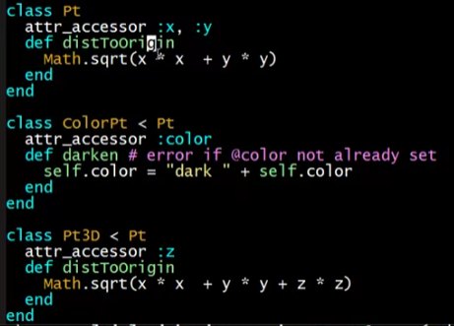

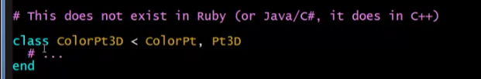

* Only one superclass in Ruby/Java/C#

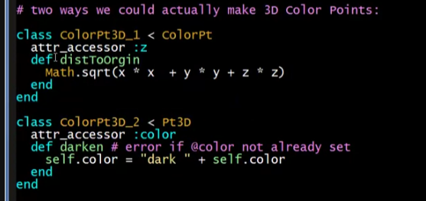

* Copying code

**Trees, dags, and diamonds**

* Note: The phrases subclass, superclass can be ambiguous
  + There are immediate subclasses, superclasses
  + And there are transitive subclasses, superclasses
* Single inheritance: the class hierarchy is a tree
  + Nodes are classes
  + Parent is immediate superclass
  + Any number of children allowed

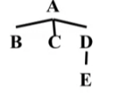

* Multiple inheritance: the class hierarchy no longer a tree
  + Cycles still disallowed (a directed-acyclic graph)
  + If multiple paths show that X is a (transitive) superclass of Y, then we have diamonds

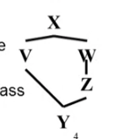

**What could go wrong?**

* If V and Z both define a method **m**
  + What does Y inherit? What does **super** mean?
    - Directed resends useful (e.g., Z::super)
* What if X defines a method **m** that Z but not V overrides?
  + Can handle like previous case, but sometimes undesirable (e.g., ColorPt3D wants Pt3D’s overrides to “win”)
* If X defines fields, should Y have one copy of them (f) or two (V::f and Z::f)?
  + Turns out each behavior can be desirable (next slides)
  + So C++ has (at least) two forms of inheritance

3DColorPoints

If Ruby had multiple inheritance, we would want ColorPt3D to inherit methods that share one @x and one @y

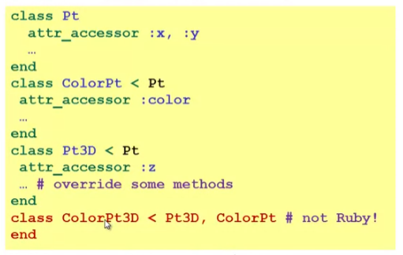

ArtistCowboys

This code has Person define a pocket for subclasses to use, but an ArtistCowboy wants two pockets, one for each draw method

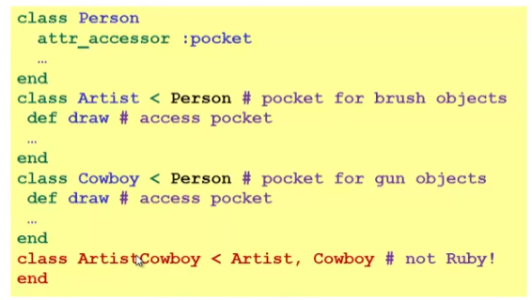

* Different *draw* method!! (different functionality)
  + Draw pictures
  + Draw weapons